Microscope photos used as a source and inspiration for my art.
Carl Hennig. Kitchener, ON, Canada
Microscopes: Bausch & Lomb (c1947-1953) with a polarizing kit (B&L)
Labomed CxL monocular with simple polarizing kit. (LoM)
Cameras: Future Optics 5MP (FO). Canon 5D MkII 21MP (5D)
Software: Adobe Lightroom image management (LR). Adobe Photoshop CS6 (PS)
Computers: HP Z420, image processing. QNAP TS-112, network attached storage.
Sunset #1
Crinkled cellophane photos layered and rotated in PS. Crossed polars, FO camera, LoM microscope.
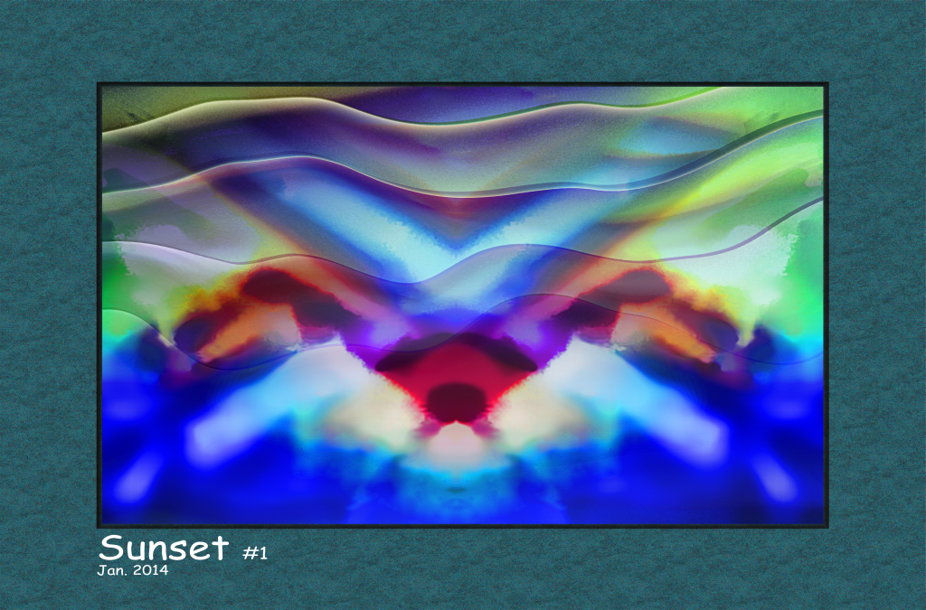 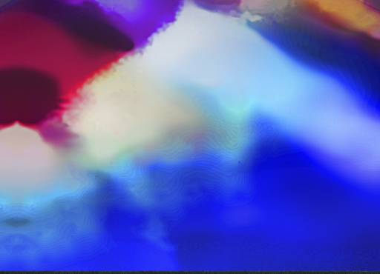
Dust etc #1
Focused on a the dust collected on an Aspergillus slide. Bausch & Lomb microscope, FO camera, PS hue and saturation and twirl distortion.
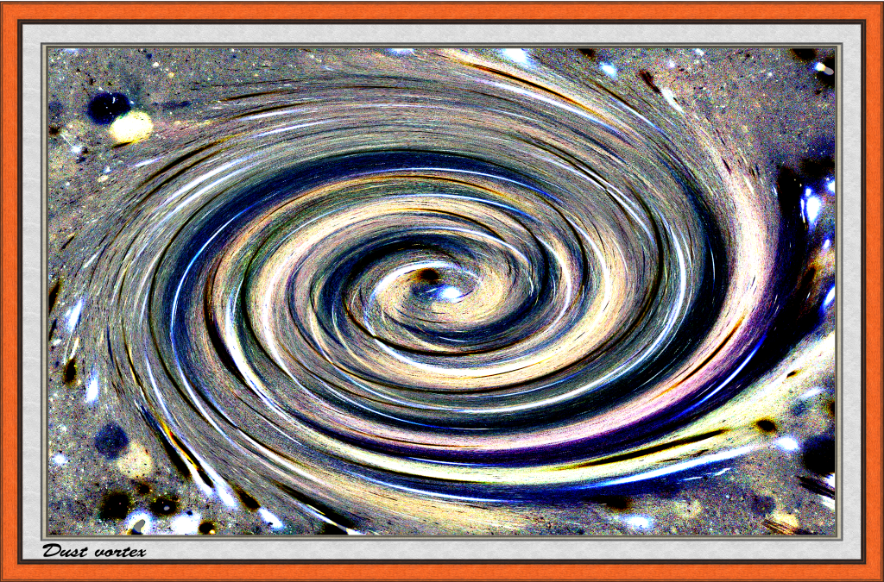
Feline deity-1
Methly Violet. Four photos of Methyl Violet masked and blended in PS
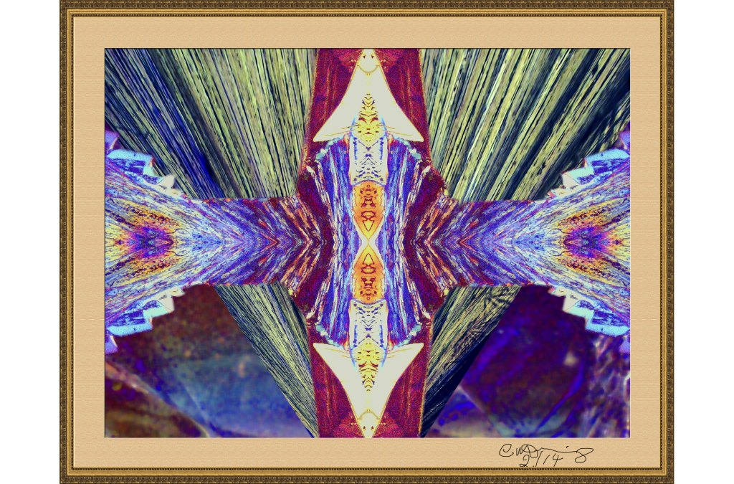 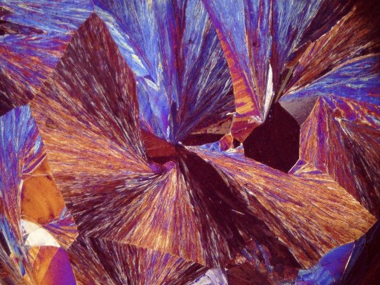
Peridotite-patches
Peridotite. Several photos of Peridotite stitched together in PS. LoM crossed polars, FO camera.
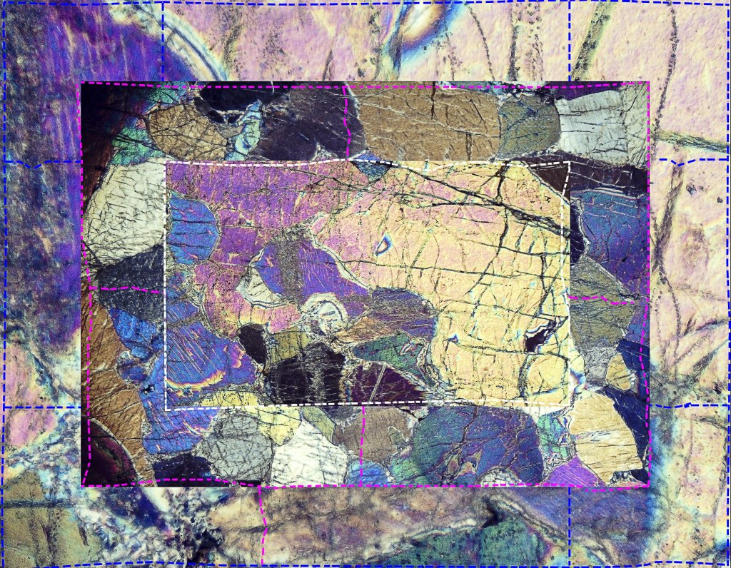 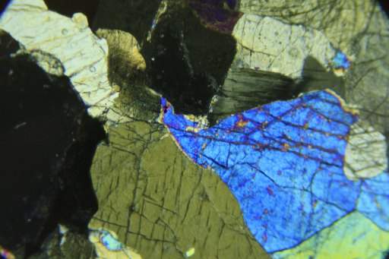
PolarMask-1.
Crinkled cellophane with Sabrina. B&L microscope, FO camera, layers and distortion in PS.
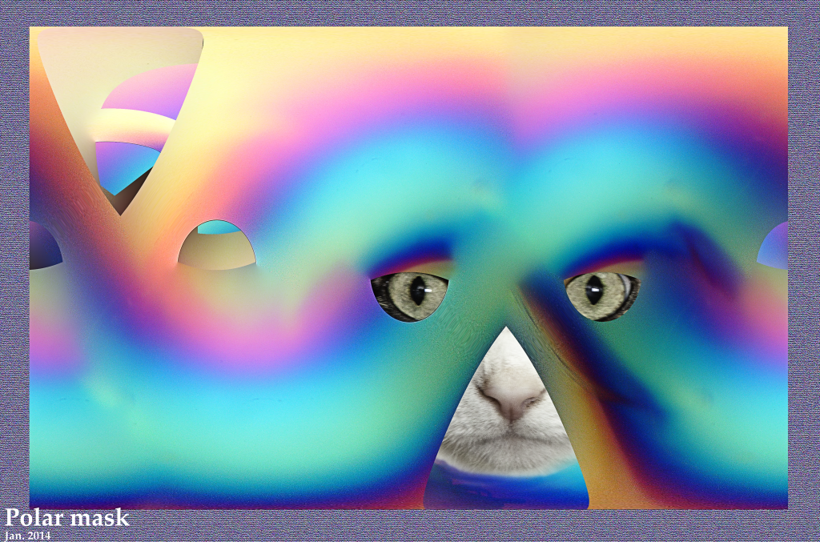 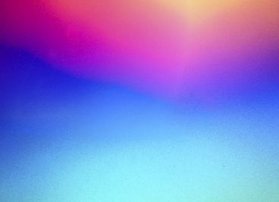
Safranin-Butterfly2x-2.
A crystal slide of Safranin. A pattern that looked a bit like a butterfly's wing. Compositing in PS. LoM microscope, crossed polars, 5D camera, 5x ocular, 2x objective.
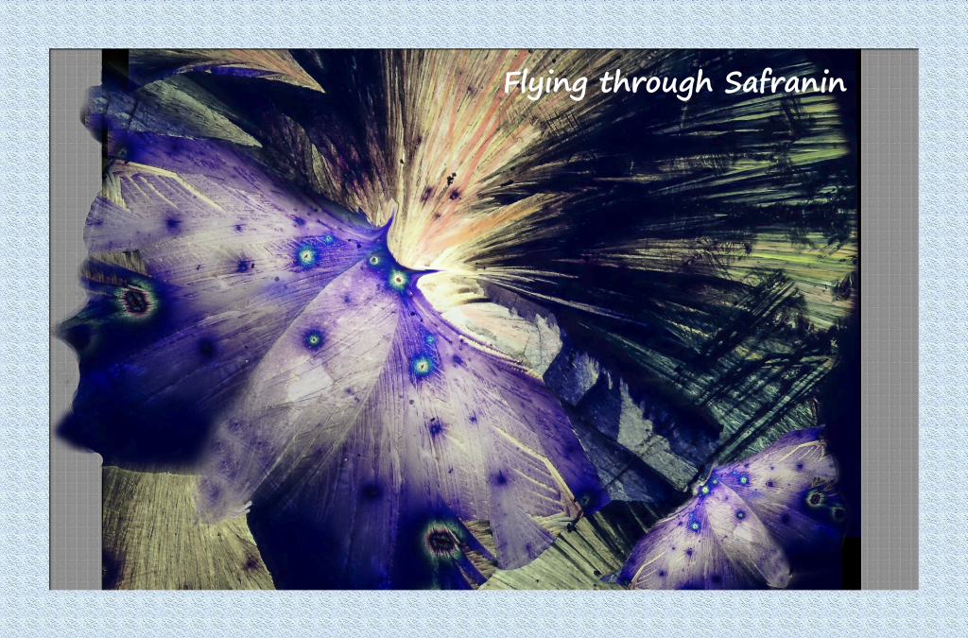 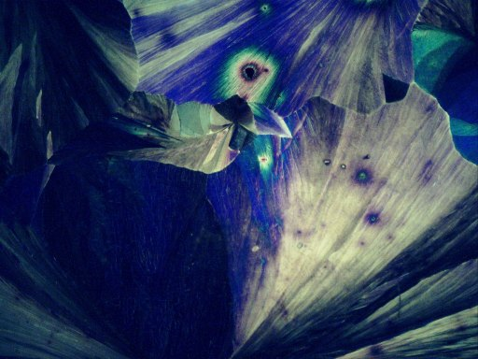
Safranin-Vision-2x.
Another Safranin pattern that looked a bit like a face. Compositing in PS. LoM crossed polars, 5D camera, 5x ocular, 2x objective.
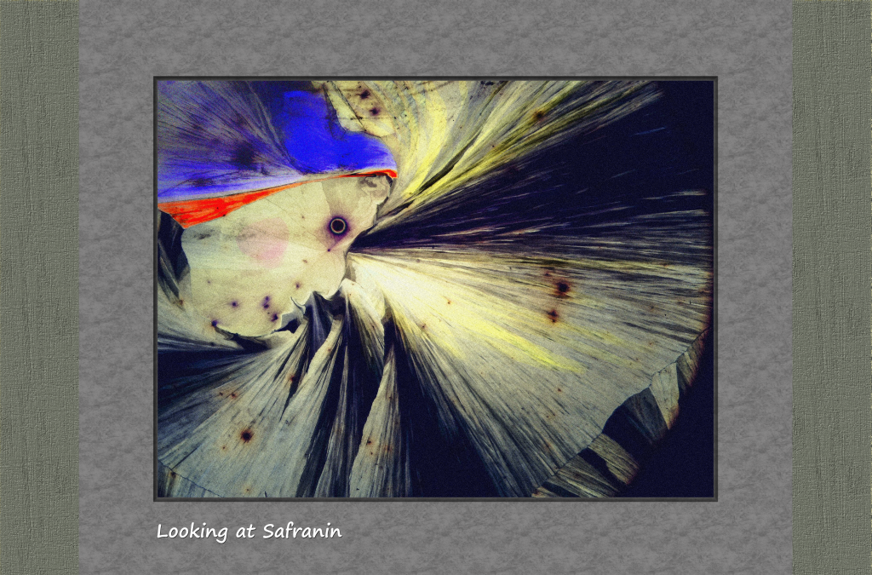
New world #1
Potassium ferricyanide crystal slide. Mapped to a sphere against a height map. LoM microscope, crossed polars, 2x obj., FO camera,


